JAM Workshop LAbO #5

Using JAM

The JAM-application automatically records samples and plays them back 'according to' the input of the user/singer. In the setup for this workshop, the samples are transposed to 3 voices (freely set to soprano, alto, tenor or bass) resulting into 4 voices (including you as a user/singer).

The rhythm is free, because the application not only follows the melody of the input, but also recognizes the tempo which therefor can be chosen and changed by the performer.

If you are planning your 'interaction' ... think of yourself as a small choir.

More information about the JAM application: http://www.jazzperiments.com.

Hearing voices

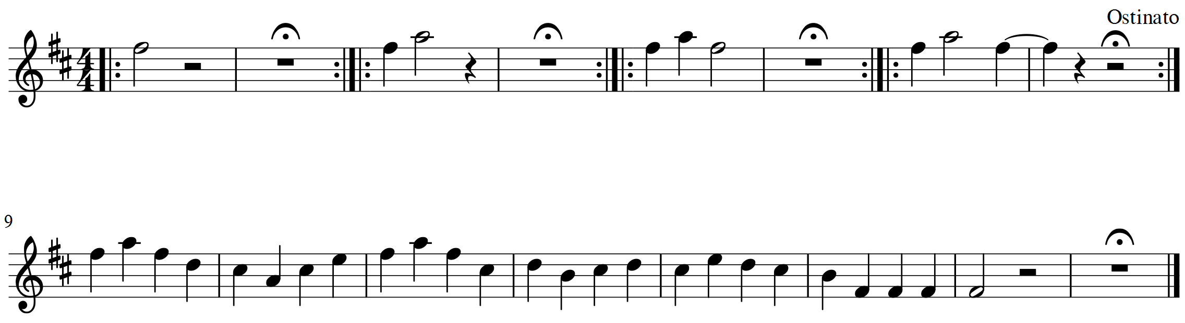

Hearing voices is set of 5 small musical themes composed to 'streamline' interaction and improvisation with the JAM-application.

The 'melody' of the first 4 themes is derived from the intonation of most natural languages: a signal, a question, a request and a demand. The fifth theme is a full 'sentence' with an answer, explanation, refusal, excuse etc. The improvisation can be slow and contemplative of fast and chaotic. 'Disturbing' results can be part of the narrative ... 'hearing voices' is also a synonym for 'auditory hallucination', a feature of some psychiatric illnesses.

The whole piece can be repeated, but this isn't required. The performer can add free improvisation.

Questions

Teun de Lange
teun@intraquest.nl
00 32 475 416 885

